**CLARINET PERFORMANCE ASSIGNMENT** #1

Play from memory 

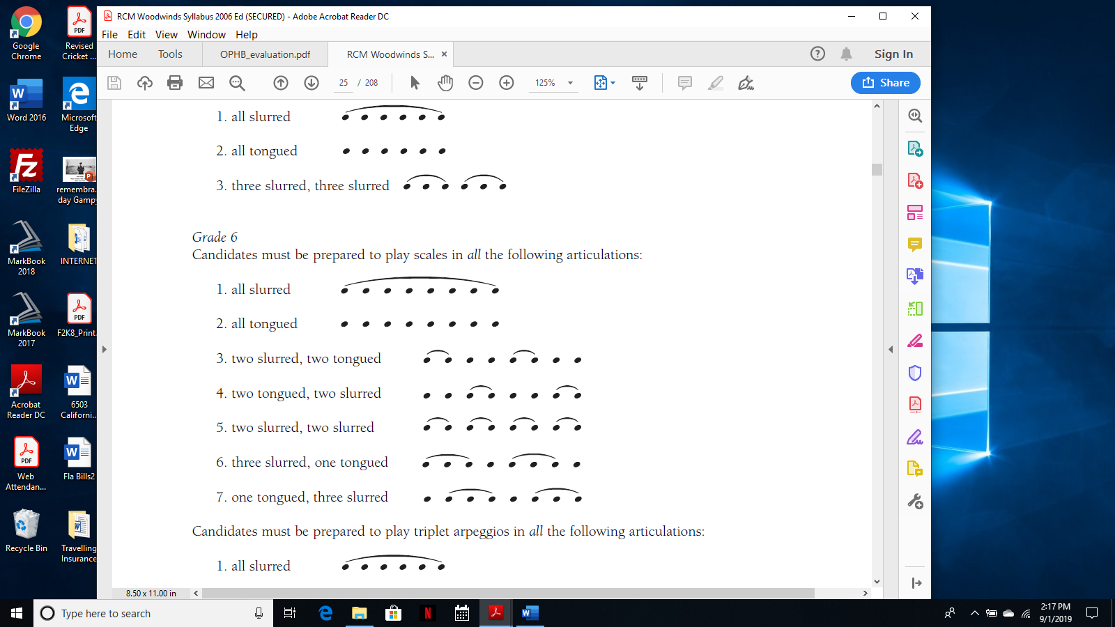



|  |  |  |  |  |
| --- | --- | --- | --- | --- |
| **KNOWLEDGE** | 01. Posture: Head/Shoulders/Arms/Feet | 8 |  |  |
| (Presentation) | 02. Hand Positions/Holding Instrument | 8 |  |  |
|  | 03. Memory | 9 |  |  |
| **THINKING** | 04. Embouchure | 8 |  |  |
| (Mechanics) | 05. Articulation | 8 |  |  |
|  | 06. Breath Support | 9 |  |  |
| **APPLICATION** | 07. Pitch Accuracy-fingerings | 8 |  |  |
| (Musicianship) | 08. Rhythmic Accuracy | 8 |  |  |
|  | 09. Tempo Consistency | 9 |  |  |
| **COMMUNICATION** | 10. Dynamic Contrast | 8 |  |  |
| (Musicality) | 11. Phrasing | 8 |  |  |
|  | 12. Tone Quality | 9 |  |  |

**Technique:** Do you demonstrate accuracy, agility and control by playing smoothly and evenly?

**05 Articulation:** Do you play articulation markings correctly?

**06 Breath support:** Are you breathing at appropriate places in the music?

**07 Fingerings:** Are you using alternate fingerings in difficult passages?

**07a Intonation:** Are you able to play in tune when moving from one note to another and through registers?

**08 Rhythm:** Are you able to hold notes and rests for the correct length? Are they precise and even?

**Interpretation:** How musically can you play?

**09. Tempo:** Do you follow tempo markings? Can you keep steady time?

**10.** **Dynamics:** Do you demonstrate a contrast in dynamics?

**11.** **Phrasing:** Do you follow phrase markings?

**12. Tone:** Is your sound rich, clear and characteristic of your instrument?

Can you control the tone in all registers and at different dynamic levels?

**13.** **Style:** Do you understand the style of the Etude?

**14.** **Musicality:** Is your performance expressive? Are your scales musical and not just technical exercises?